Matthew Howa

U0805396

Computer Graphics – HW 2

Image Compression

For this assignment I wrote code to compress images and audio files. Using the DCT algorithm to restructure the bits, I accomplished levels of compression by zeroing out any number of trailing zeros except the first and then transforming the bits back using Inverse DCT.

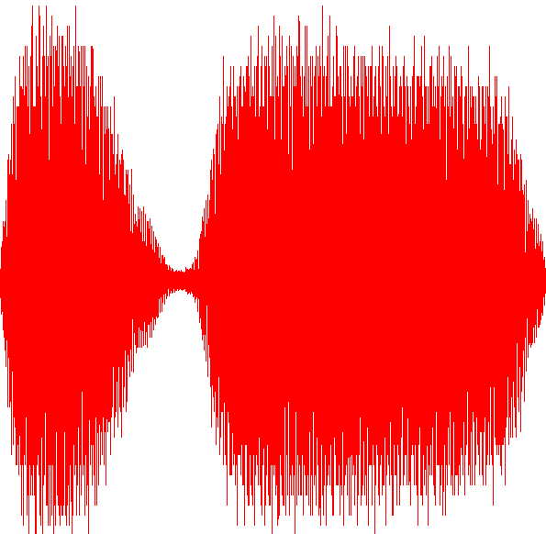 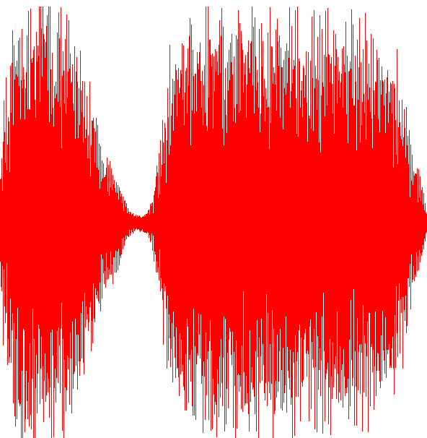

Train: Before Train: After

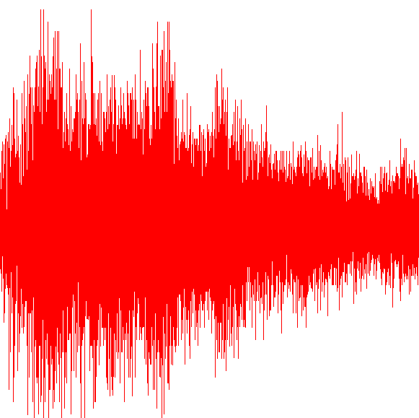 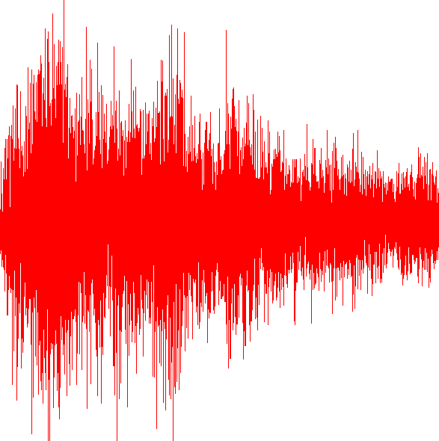

Gong: Before Gong: After

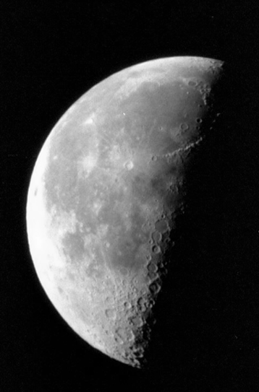 n=1 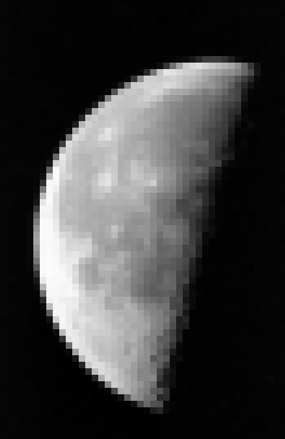

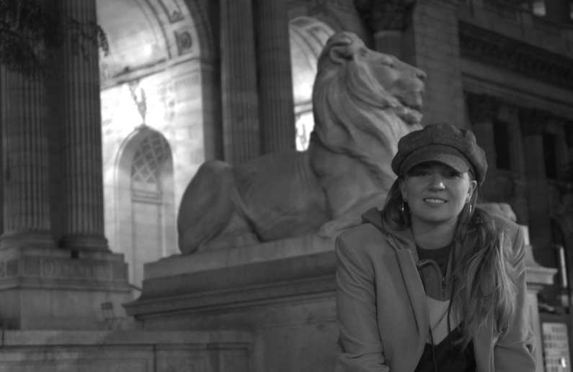 n=1 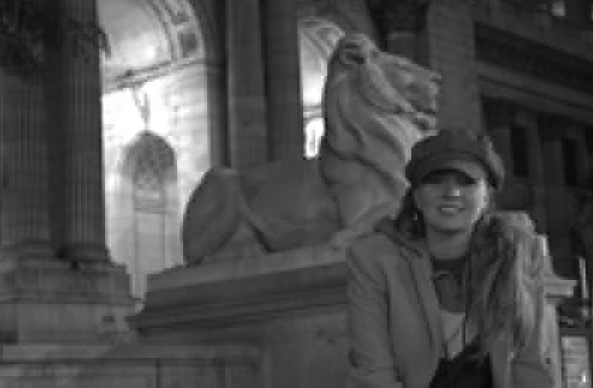

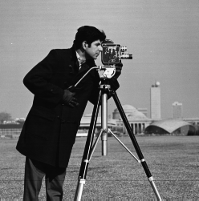 n=1 